

**BAOBAB HEALTH TRUST**

**STANDARD OPERATING PROCEDURE (SOP) FOR EVR SYSTEM EQUIPMENT**

The aim for this document is to clearly describe the procedures or steps that are taken in assembling the electronic village register (EVR) system.

In this explanation the concentration is dwelling much on the desk setup, the desk itself has compartments for handling the system of which it consists of;

* **BATTERY BOX (24V DC )**

The battery box supports two 12volts batteries connected in series for powering up the system, it is placed at the bottom part of the desk. It comes separate with its lid thus for covering batteries, before covering the batteries there are steps that follow, drilling a hole for the speakon connector after that soldering of a female speakon connector which works as a battery bank power output port, see images below.

 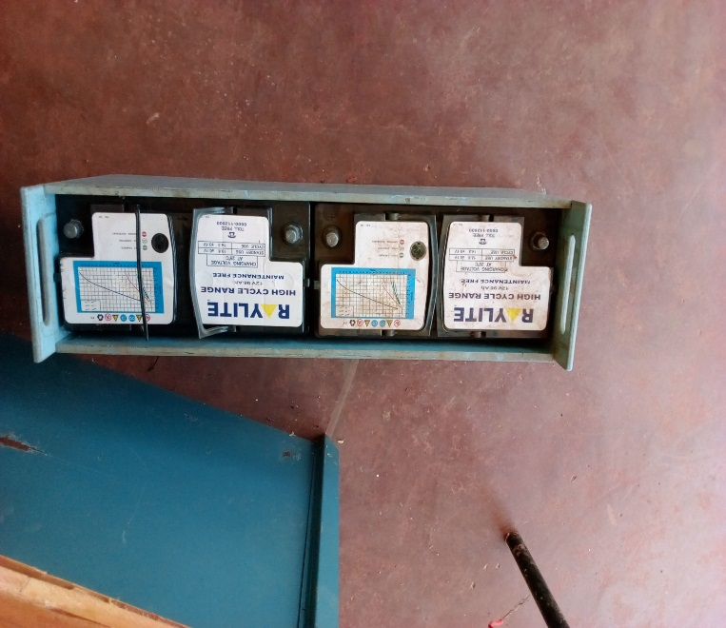

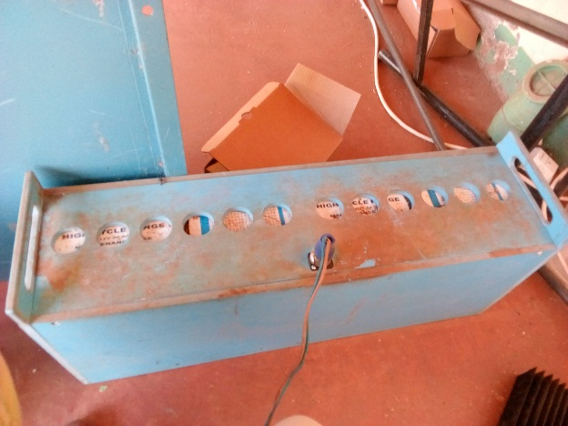 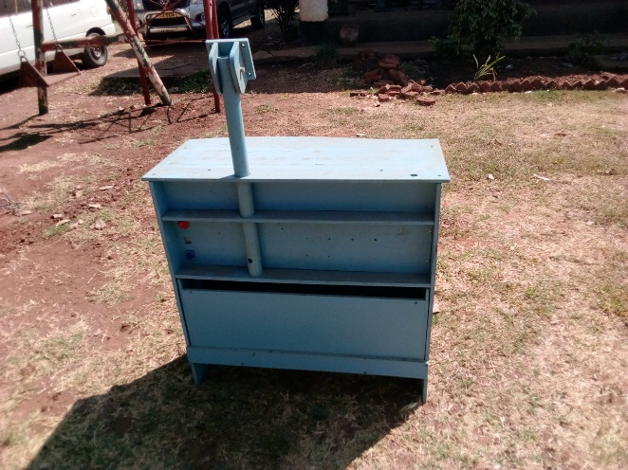

* **ELECTRONIC SYSTEM UNIT**

Also known as the equipment panel. This part supports 4Dc to Dc power supply modules a solar charge controller, and an ATA, below is an image of the equipment panel without accessories (dc to dc power supply modules, solar charge controller and ATA)

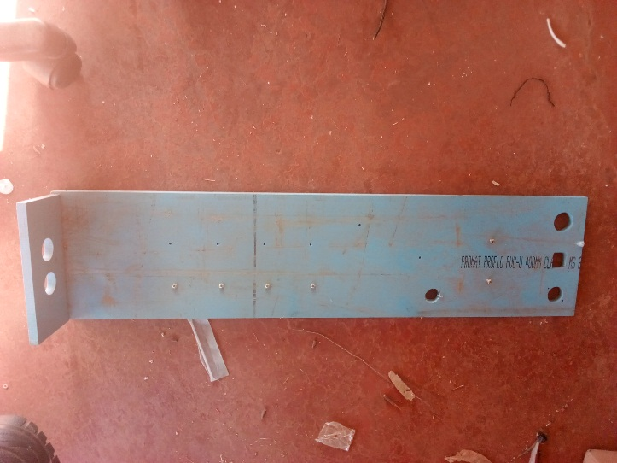

* **TWO 12VOLTS CIGARETE PORTS**
* **SCANNER STAND**

A hole is drilled on the right hand side whereby a scanner is mounted on the side for the support of the scanner.